NATIONAL INCIDENT MANAGEMENT SYSTEM

NIMS/ICS/NIMSCAST

This page intentionally left blank

NATIONAL INCIDENT MANAGEMENT SYSTEM (NIMS)

This page intentionally left blank
What is NIMS?
NIMS is the National Incident Management System. The NIMS is intended to provide a consistent, flexible, and adjustable national framework to enable first responders at all levels of government along with the private sector and nongovernmental organizations to work together effectively and efficiently to prepare for, prevent, respond to, and recover from disasters, regardless of cause, size, or complexity, including acts of catastrophic terrorism. Based upon this goal, the NIMS consist of six components:

- Command and Management (ICS)
- Preparedness
- Resource Management
- Communications & Information Management
- Supporting Technologies
- Ongoing Management and Maintenance.
Implementation of NIMS
In order to preserve the eligibility of the State and local governments for federal preparedness assistance, New Hampshire passed legislation (RSA 21P-52) that established NIMS as the State standard for incident management and requires:
- NIMS to be used on all emergency incidents
- First responders and other officials to complete NIMS training
- Incorporation of NIMS into Emergency Operations Plans, standard operating procedures or guidelines and other plans and procedures
- Training programs to incorporate NIMS concepts for first responders to conduct exercises and drills utilizing NIMS.

Required NIMS Training
Compliance with the National Incident Management System (NIMS) is a prerequisite to obtaining any federal preparedness assistance (“grants or contracts that contribute to building preparedness and response capabilities”). Federal preparedness assistance includes (but is not limited to) the Assistance to Firefighters Grant Program, the Homeland Security Grant Program, the Urban Area Security Initiative Grant Program, the Staffing for Adequate Fire and Emergency Response Grant Program, and the CDC Public Health Emergency Preparedness Cooperative Agreement.

Answering the following question provides the most basic analysis of who should get NIMS training: “Does the person have incident response, asset coordination or policy setting responsibility for response efforts?” If the answer is yes to any of these, then NIMS training is needed.
First Responder Definitions
The definitions of “First Responder” in Homeland Security Presidential Direction 8 (HSPD-8) and the Homeland Security Act are much broader than fire, emergency medical, law enforcement, and emergency management.

The term “first responder” refers to those individuals who in the early stages of an incident are responsible for the protection and preservation of life, property, evidence, and the environment, including emergency response providers as defined in Section 2 of the Homeland Security Act of 2002 (6 U.S.C. 101), as well as emergency management, public health, clinical care, public works, and other skilled support personnel (such as equipment operators) that provide immediate support services during prevention, response, and recovery operations (HSPD-8).

The term “emergency response providers” includes Federal, State, and local emergency public safety, law enforcement, emergency response, emergency medical (including hospital emergency facilities), and related personnel, agencies, and authorities (Homeland Security Act – 6 U.S.C. 101).

Local Implementation Checklist
Adopt NIMS by ordinance or resolution (see your HSEM Field Rep for a sample resolution/ordinance). The State has adopted NIMS pursuant to RSA 21P-52. Local jurisdictions are required by the Department of Homeland Security to adopt NIMS by ordinance or resolution.

- Assess current training levels for first responders and train to appropriate level
- Provide ICS Executive Summary to all elected officials
- Incorporate NIMS into the Emergency Operations Plan
- Establish public information system to gather, verify coordinate and disseminate information during an incident
- Develop systems and processes to ensure that incident managers at all levels share a common operating picture of an incident
- Designate a single point of contact to serve as the principal coordinator for NIMS implementation
- Incorporate NIMS into all standard operating procedures, guidelines or other operational documents
- Incorporate NIMS into existing training programs
- Use NIMS on a day-to-day basis
- Formalize mutual aid agreements with other jurisdictions
- Participate in multi-discipline/multi-jurisdictional all-hazards exercises using NIMS concepts
- Conduct after action reviews of large incidents and exercises and incorporate lessons learned into plans, policies and procedures
- Apply standardized and consistent terminology, including the establishment of plain English communications standards across public safety sector
- Inventory community response assets to conform to homeland security resource typing standards.
What level of training is required?
ICS-100, Introduction to ICS – All first responders. This course introduces the Incident Command System (ICS) and provides the foundation for higher level ICS training. ICS-100 describes the history, features and principles, and organizational structure of the Incident Command System. It also explains the relationship between ICS and the National Incident Management System (NIMS).
ICS-200, Basic ICS – First line supervisors, single resource leaders, lead dispatchers, field supervisors, and company officers. ICS 200 is designed to enable personnel to operate efficiently during an incident or event within the Incident Command System (ICS). ICS-200 provides training on and resources for personnel who are likely to assume a supervisory position within the ICS.

ICS-300, Intermediate ICS – State of New Hampshire requires all Fire Service Chief Officers regardless of department size and Police Chief Officers if the permanent force exceeds 50 Officers. This course covers organization and staffing, organizing for incidents and events, resource management, and air operation.
ICS-400, Advanced ICS – State of New Hampshire requires all Fire Service Chief Officers regardless of department size and Police Chief Officers if the permanent force exceeds 50 Officers. This course expands upon the material covered in ICS 100 through ICS 300. ICS 400 focuses on large single-agency and complex multi-agency/multi-jurisdictional incident response. The course addresses area command and staff issues, as well as the planning, logistical and fiscal considerations associated with complex incident management and interagency coordination.

ICS-402 – Incident Command System Summary for Executives – Elected officials, senior executive, senior managers and agency administrators with policy responsibilities but without specific ICS or Multi-Agency Coordination System. This course defines the role of an Executive relative to the ICS. ICS-402 also describes the following: the various ways ICS can be applied, the basic organization of ICS and the functional responsibilities of the Command and General Staffs, basic ICS terminology, and the major responsibilities of an Executive as related to an incident/event; identifies the differences between incident/event ICS organizations and the activities accomplished by Area Commands, Emergency Operations Centers (EOCs) and Multi-Agency Coordination Systems (MACS); and explains the administrative, logistical, financial and reporting implications of large incident/event operations.
IS-700 National Incident Management System (NIMS), An Introduction – All persons with response, command or response policy responsibility. This course introduces NIMS and explains the purpose, principles, key components and benefits of NIMS.
IS-800.B, National Response Framework, An Introduction – All State, County, and local Emergency Managers. The course introduces participants to the concepts and principles of the National Response Framework. IS-800.b describes how the Federal Government will work in concert with State, local, and tribal governments and the private sector to respond to disasters.

Who are the State NIMS Points of Contact?
NIMS Compliance Point of Contact: Richard Verville, Planning Officer
Homeland Security and Emergency Management
Office Phone — (603) 271-2231
FAX — (603) 223-3609
NIMS Exercise Point of Contact: Exercise Planning Officer
Homeland Security and Emergency Management
Office Phone — (603) 271-2231
FAX — (603) 223-3609

NIMS Training Point of Contact: Robert Pragoff, Training Officer Fire Standards and Training
Office Phone — (603) 271-2661
FAX — (603) 271-1091
Homeland Security Grant Program Point of Contact: Pam Urban-Morin, Grants Manager Department of Safety
Office Phone — (603) 271-7033
FAX — (603) 271-3903
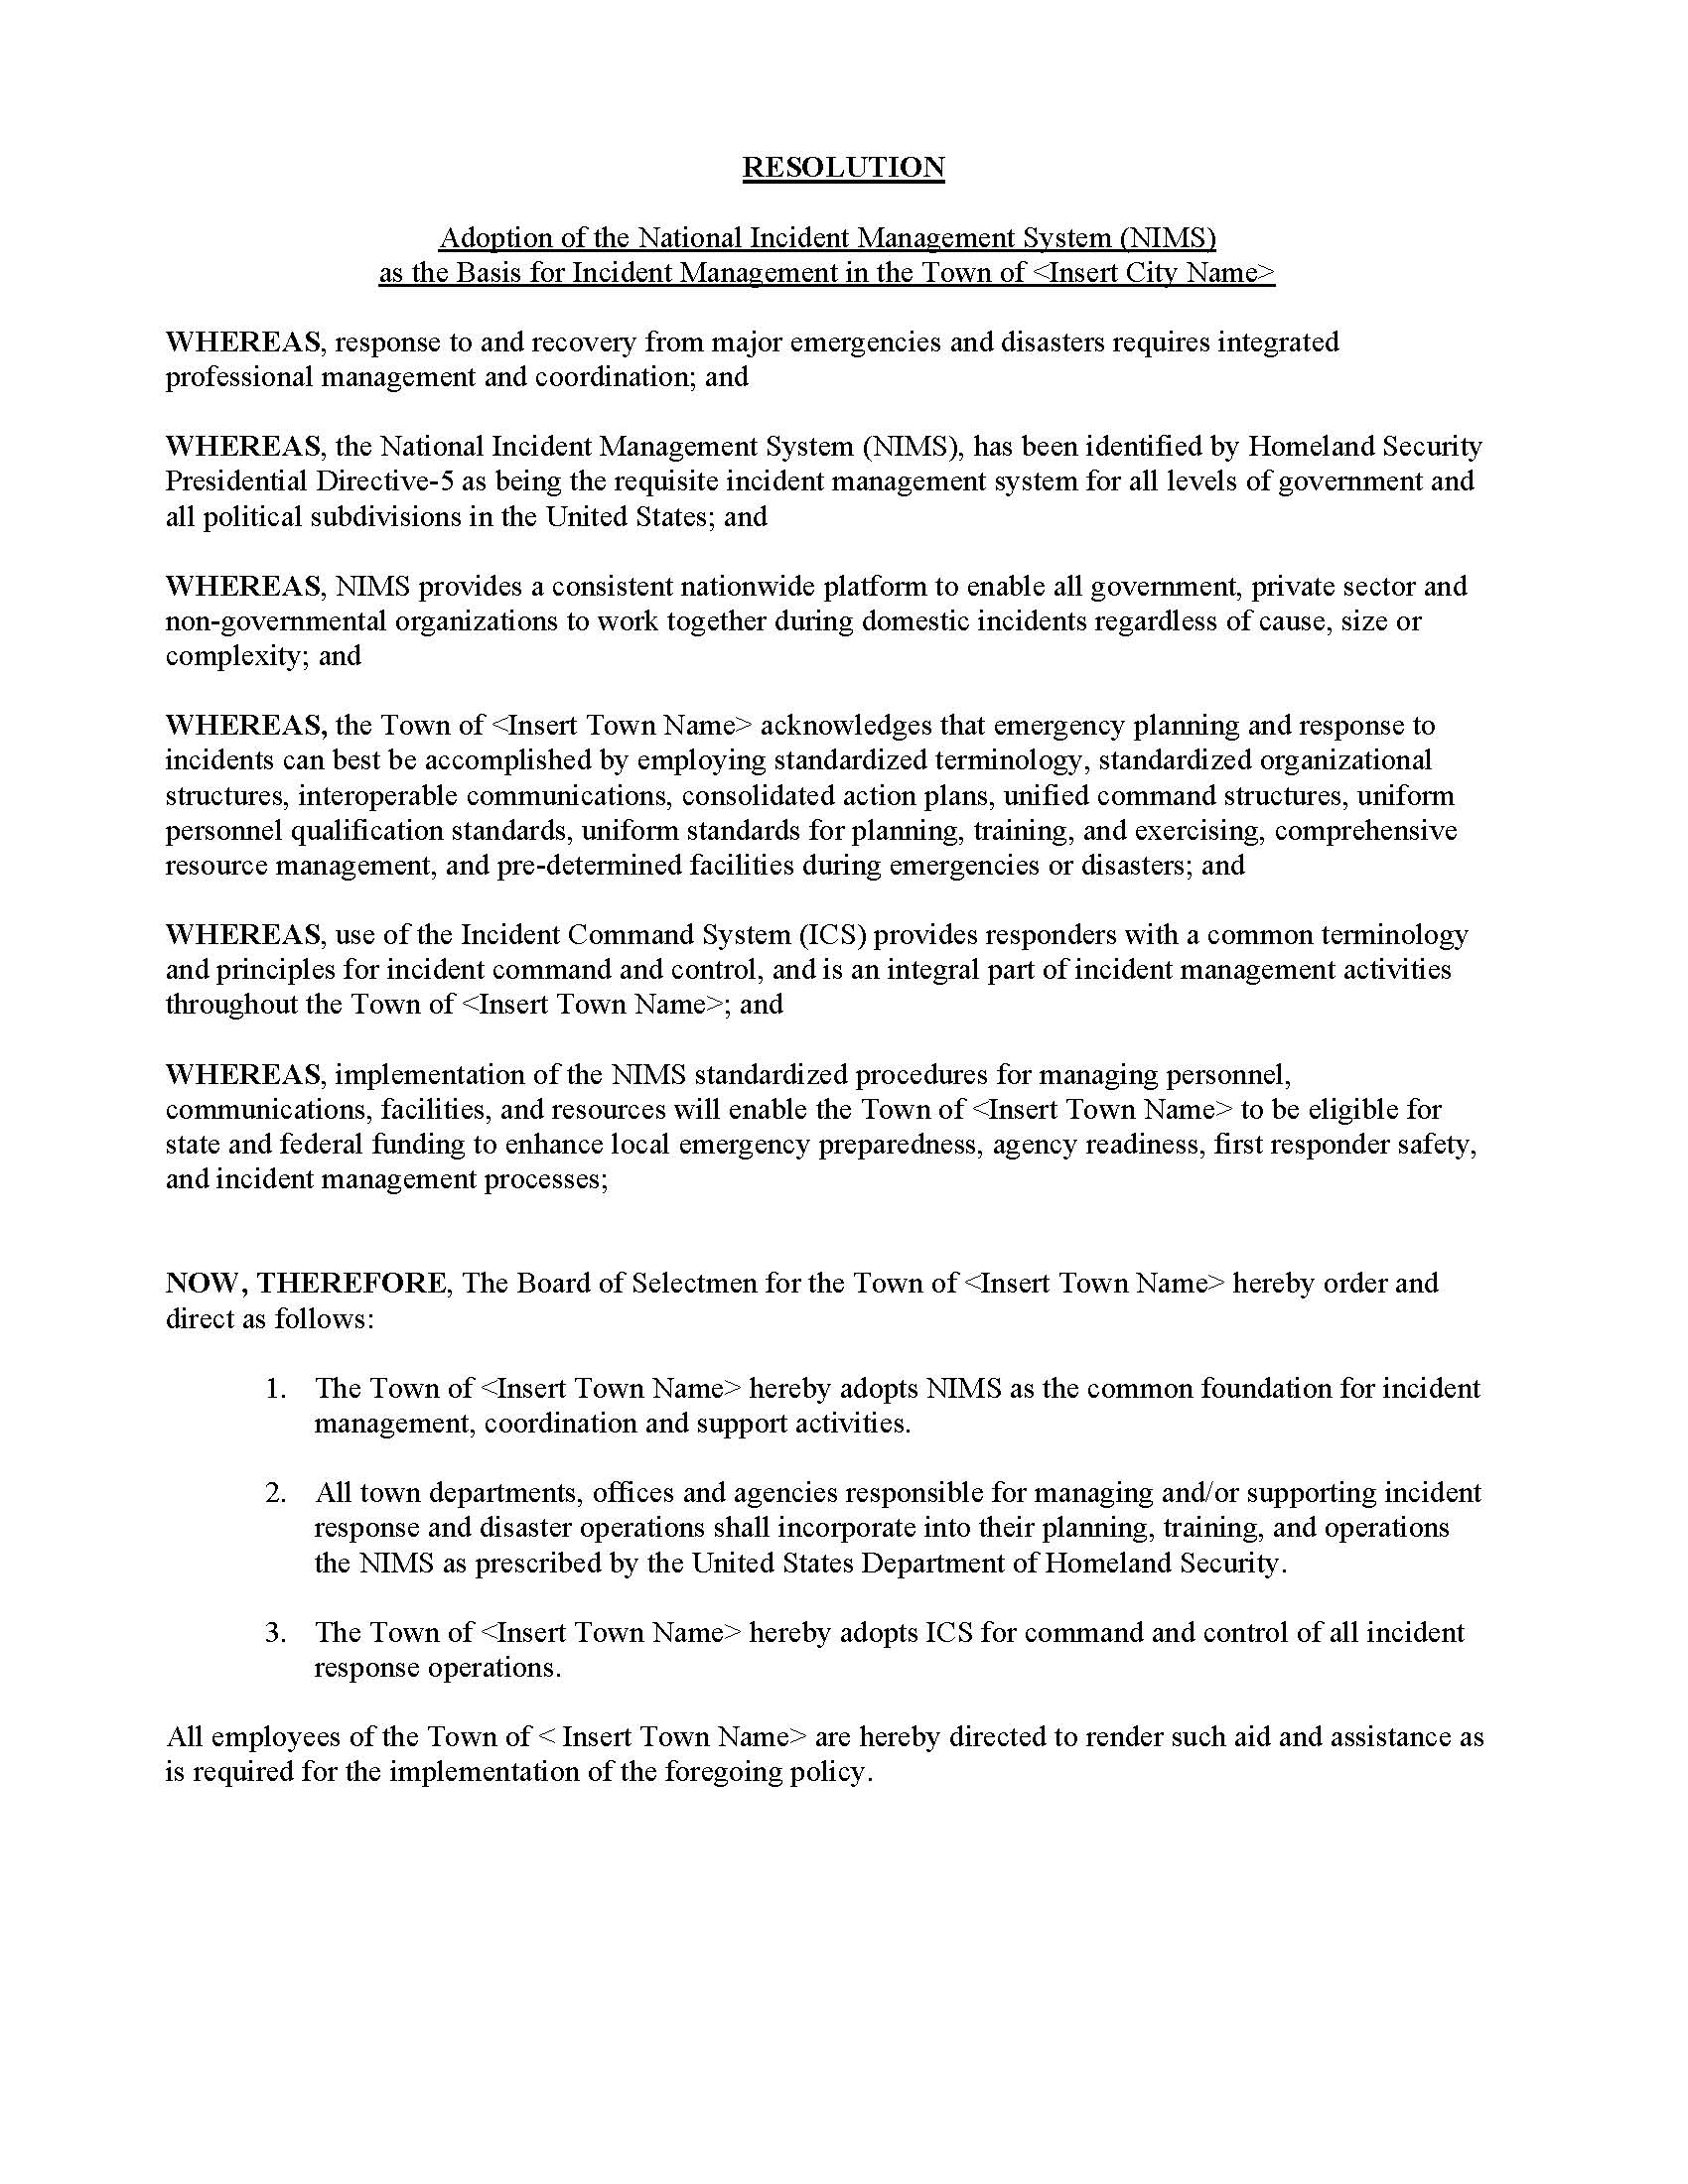

This page intentionally left blank
NIMS COMPLIANCE ASSISTANCE SUPPORT TOOL (NIMSCAST)

This page intentionally left blank

NIMSCAST OVERVIEW

In order for communities or agencies to be eligible for ANY Homeland Security Preparedness Grant Funds (Homeland Security Grant, Exercise Grants and the Emergency Management Performance Grant, etc.), it is required that they provide documentation showing their National Incident Management System (NIMS) compliance. This must be done by accessing NIMSCAST (formerly known as NIMCAST).

What is NIMSCAST?

The NIMS Compliance Assistance Support Tool (NIMSCAST) is designed as the comprehensive, web-based self-assessment instrument for the emergency management community in State and Local governments to evaluate and report their jurisdiction’s achievement of all NIMS implementation activities released since 2004.

Using the NIMSCAST will assist the nation’s emergency management community to comply with NIMS requirements, as determined by the National Integration Center.

Additionally, Homeland Security Presidential Directive-5 (HSPD-5) requires federal departments and agencies to mandate State and Local government and organizations to adopt NIMS as a condition for Federal preparedness assistance. The NIMSCAST facilitates the adoption of the NIMS by State and Local governments in order to meet these requirements.

How do I access the NIMSCAST?

To gain access to this system each community must:

- Formally appoint a NIMS Point of Contact (POC) for your community and notify your community’s HSEM Field Representative. The POC must have sufficient computer knowledge and skills to complete this web-based assessment.

- Once the POC’s contact information and permissions have been entered in NIMSCAST by their community’s assigned HSEM Field Representative, they will receive an e-mail from NIMSCAST with a hyperlink that takes them to the website. This hyperlink gives them temporary access to the NIMSCAST website for only 24 hours.

- Local users must click on this hyperlink and go to the website (within 24 hours, or they will be automatically deactivated).

- Once local users get on the website, the first thing they should do is go to the “Change Password” button and follow the directions to enter their own (easy-to-remember) password.

- Once this step is completed, users should get a reply back stating “Password changed successfully”. Once users have established their own passwords, they can now log onto the website at anytime. Be sure to click on the “Log Out” button when you are finished with the website.

NIMSCAST OVERVIEW
(continued)

- It is not recommended to do the on-line surveys using dial-up internet access. Dial-up is too slow and very prone to dropping out without any warning.

The NIMSCAST Technical Users Guide will articulate enhancements to the NIMSCAST in FYs 2007-2008 and provide specific steps in how to best use the system. The table of contents is linked to major and sub-parts of various features in the NIMSCAST. You can access the user guide by going to this link: https://www.fema.gov/nimscast/img/pdf/NimcastUsersGuide.pdf

When viewing this document on your computer, place your mouse cursor over an item in the table of contents and left click your mouse. This will allow you to jump to a specific topic area.

FOR FURTHER INFORMATION AND ASSISTANCE WITH NIMSCAST, PLEASE CONTACT YOUR COMMUNITY’S ASSIGNED HSEM FIELD REPRESENTATIVE.

