MISCELLANEOUS EMERGENCY MANAGEMENT MATERIAL

This page intentionally left blank

Sample HSEM eNewsletter – If you are currently not on our email distribution list to receive the HSEM eNewsletter, please contact your assigned HSEM Field Representative. 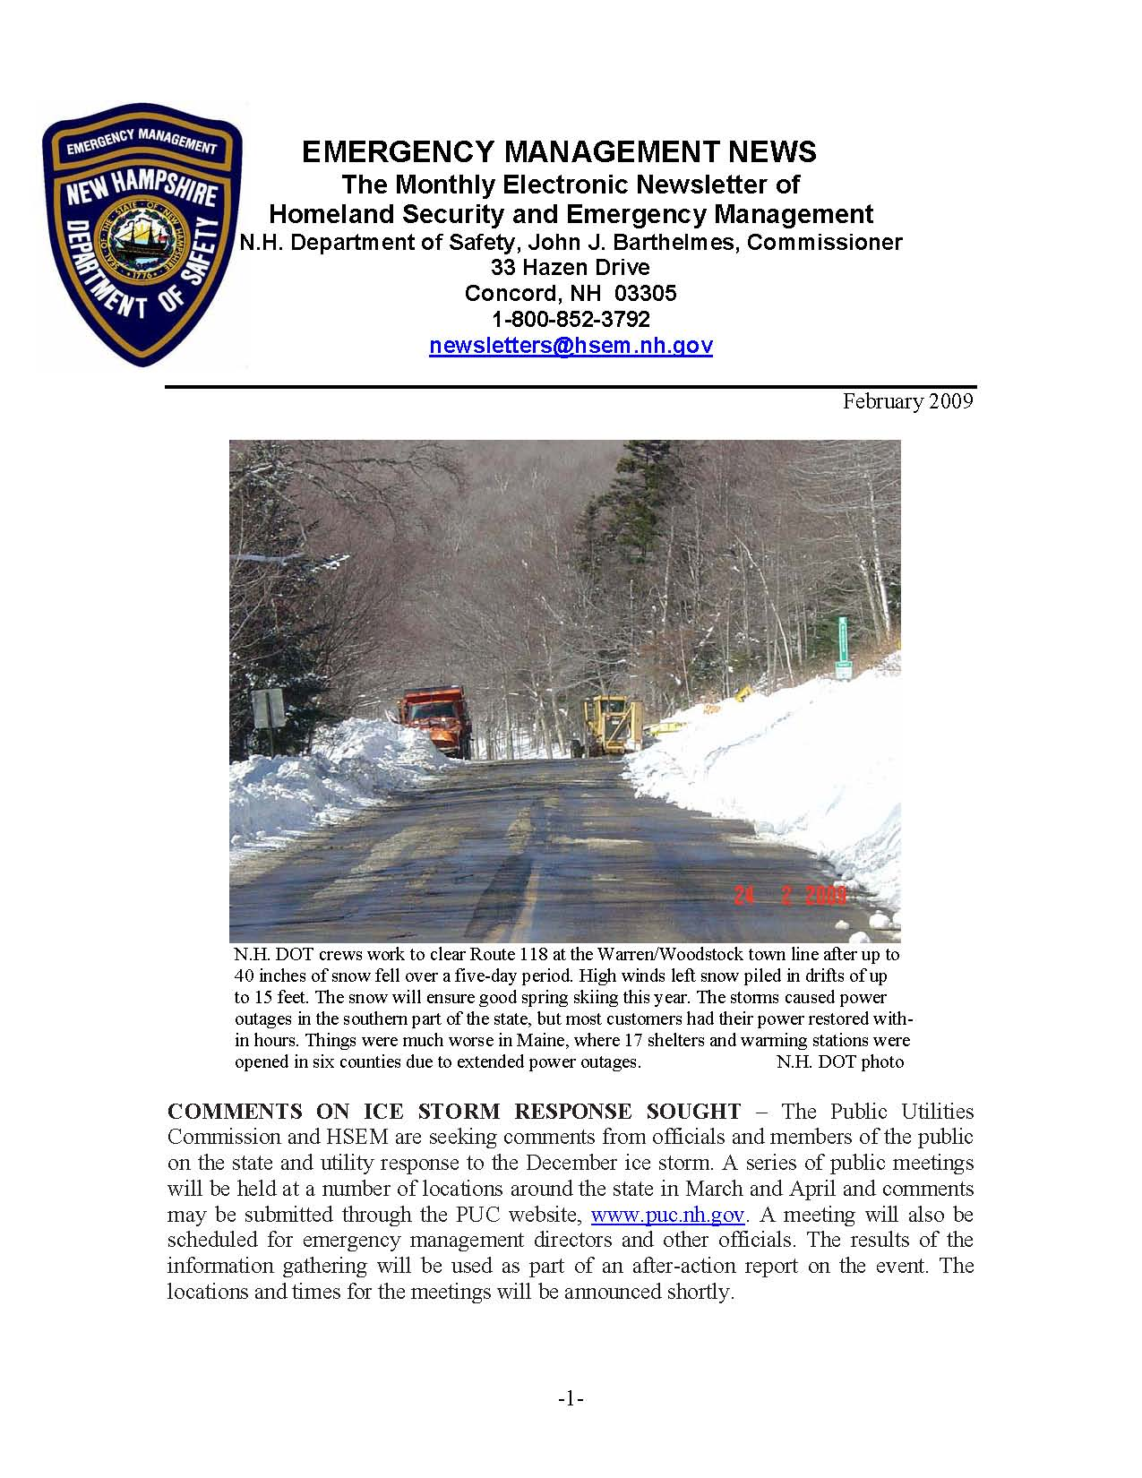
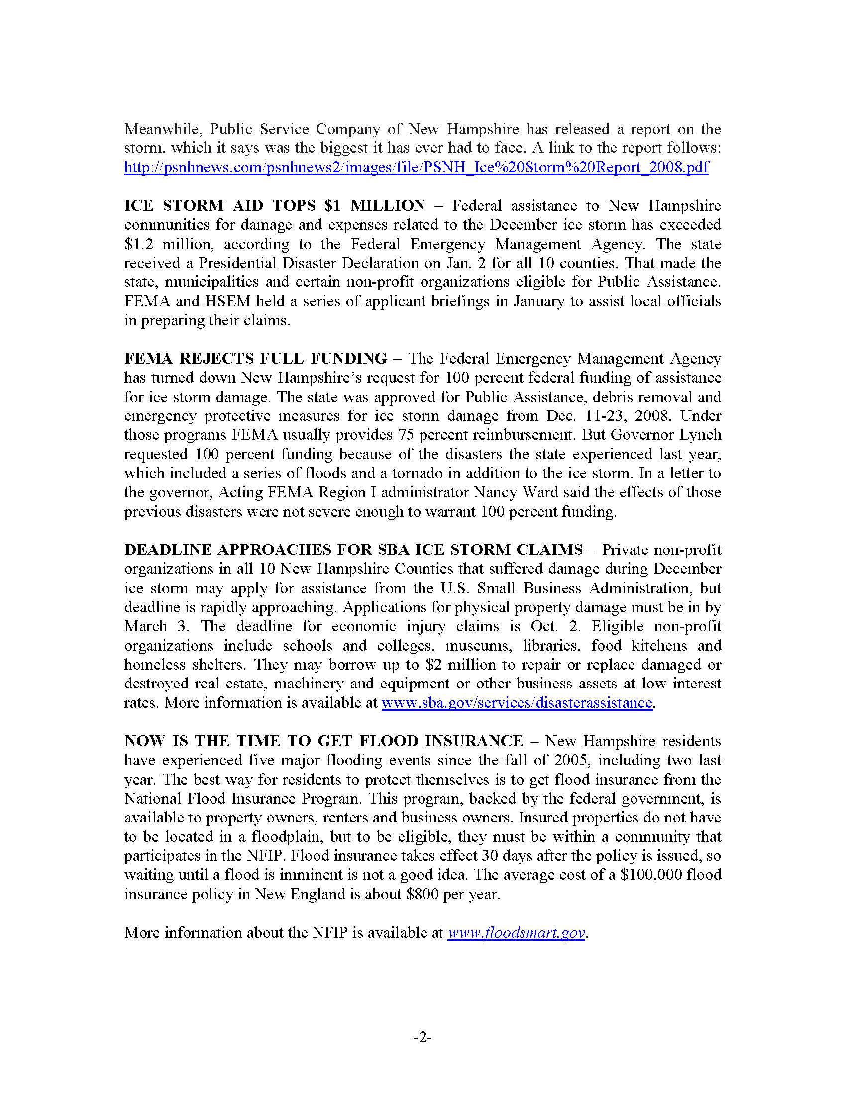
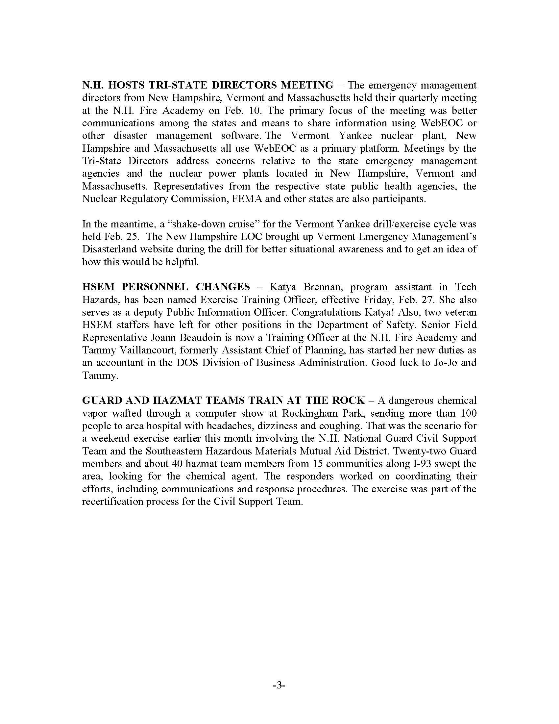
This page intentionally left blank

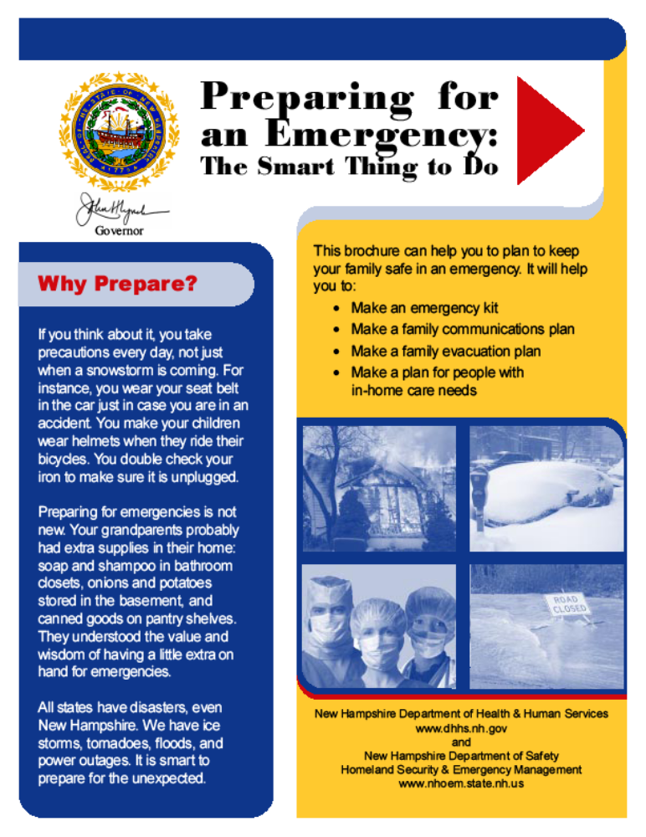

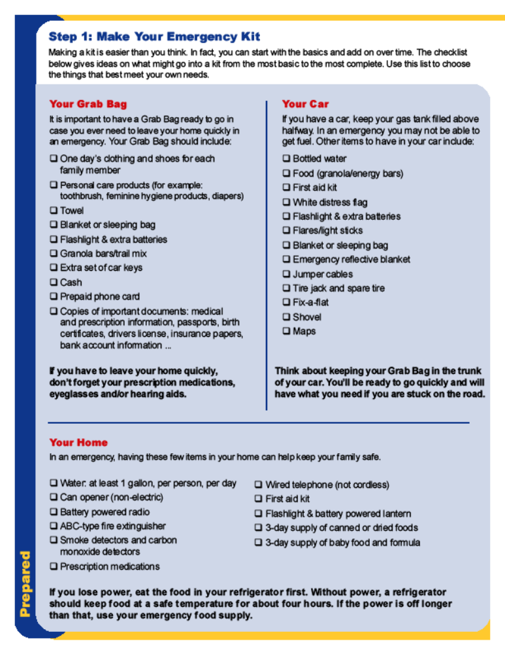
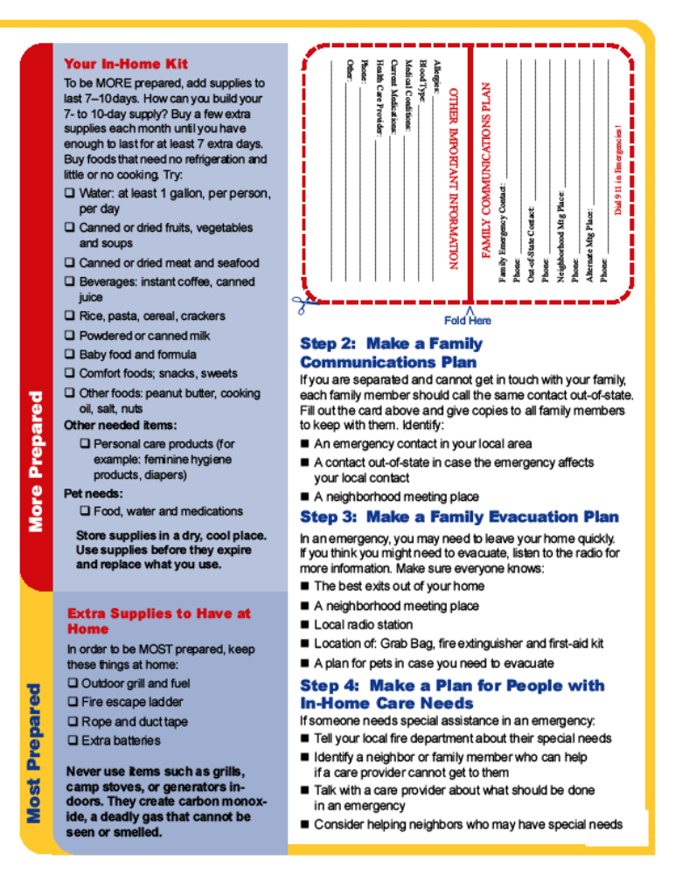
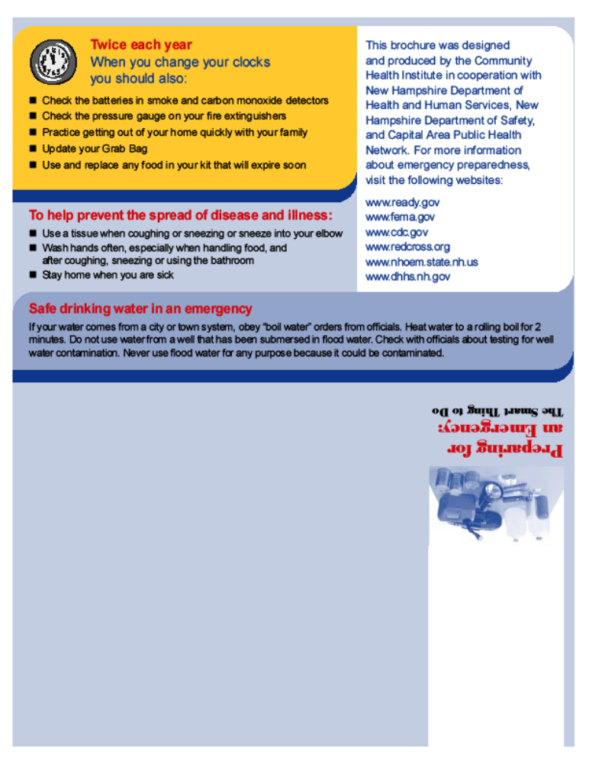

MISCELLANEOUS EMERGENCY MANAGEMENT RELATED

HANDOUTS AND BROCHURES

This page intentionally left blank

