GRANTS

        - Emergency Management Performance Grant (EMPG)

        - Hazard Mitigation Grant Program (HMGP)

        - Flood Mitigation Assistance (FMA) Grant

        - Pre-Disaster Mitigation (PDM) Grant

        - NH Homeland Security Grant Program

This page intentionally left blank
EMERGENCY MANAGEMENT
PERFORMANCE GRANT
(EMPG)

For the most current EMPG Application and Guidance Document, please contact your assigned HSEM Field Representative


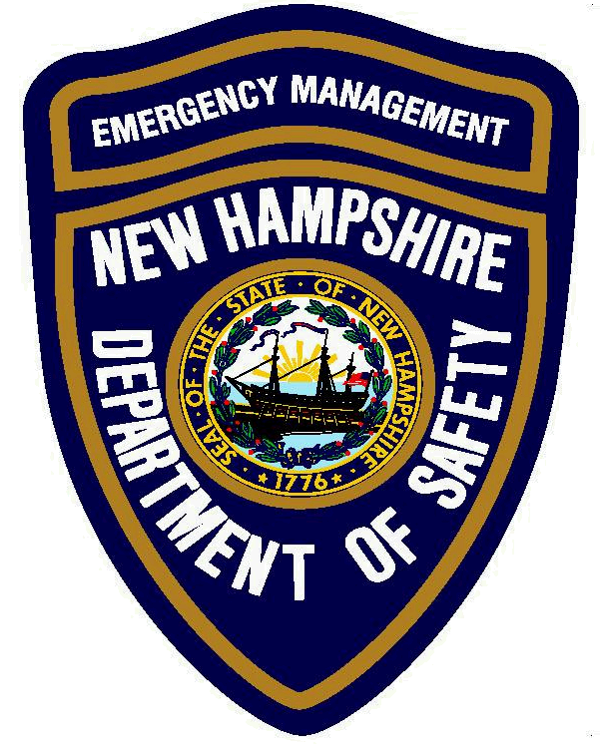State of New Hampshire Department of Safety
John J. Barthelmes, Commissioner
Earl M. Sweeney, Assistant Commissioner
Homeland Security and Emergency Management
Christopher M. Pope, Director
Kathryn E. Doutt, Assistant Director

July 1, 2008

Dear Local Official:

NH Department of Safety, Homeland Security and Emergency Management (NH HSEM) has received the FY08 Emergency Management Performance Grant (EMPG) from the Department of Homeland Security and Emergency Management that will be distributed to local communities through a competitive grant process, pending Governor and Council approval. EMPG grant funds are specifically targeted to measurably improve all-hazard planning and preparedness capabilities/activities, to include mitigation, preparedness, response, and recovery initiatives.

Please be aware that this is a grant program; therefore, your community will receive funds for approved projects before the projects have been completed. Please be especially mindful to only apply for projects that you are confident you can accomplish in the timeframe allowed by the grant period. The initial application deadline is September 30th. After that date, eligible and complete applications will be processed as received.

Additionally, please pay close attention to the grant application. There have been many changes in the grant guidance thus causing changes in the application. Further, please ensure that all applications are complete before sending them in. As noted on the application, incomplete applications will cause a delay in processing and will be returned to the requesting organization after other complete applications have been processed.

The grant period ends September 30, 2009 with a final expenditure and performance report due by October 31, 2009. There is a 50% match requirement associated with these EMPG funds, which may be in the form of either cash (hard) or in-kind (soft) match monies. The applicant will be required to retain all records of expenditures, including matching funds, for a period of four (4) years from the grant end date.

EMPG Grant
Page 2
July 1, 2008

The grant process will be as follows:

- Applications received by NH HSEM.
- Applications will be reviewed by NH HSEM.
- Grant Agreements will be mailed to communities for approved projects.
- Grant Agreements need to be signed, notarized, and mailed back to NH HSEM.
- NH HSEM will process signed Grant Agreements for Governor and Council (G&C) approval.
- Once approved by G&C, checks will be processed for payment.

Applications and supporting documentation should be forwarded to:

NH Department of Safety
Homeland Security and Emergency Management
Attention: Richard Verville
33 Hazen Drive
Concord, NH 03305

If you have any questions please feel free to contact your Field Representative or myself at 1-800-852-3792 or 271-2231.

Enclosures

cc: HSEM Field Representative

NH Department of Safety
Homeland Security and Emergency Management
EMPG Grant Application
FY 08

Application Deadline: September 30, 2008.

- Requesting Organization: ____________________________________________

Grant Coordinator Name & Title

__________________________________________________________________
Street Mailing Address

__________________________________________________________________
Community, State, Zip Code

E-Mail Telephone Number

2. 100% of Grant Funding Request: ________________________________________
(Grant amount awarded will, at a maximum, be 50% of above requested amount.)

2a. Total number of projects in application _______________

2b. List each project by Title and Funding Requested.

________________________________________________ $___________

________________________________________________ $___________

________________________________________________ $___________

________________________________________________ $___________

________________________________________________ $___________

________________________________________________ $___________

________________________________________________ $___________

FY 08 EMPG Grant Application
Page 2 of 3

3. Local municipalities must report NIMS compliance via NIMCAST to be eligible for EMPG 08 funding. A copy of the NIMCAST “Summary of Assessment” report is required to be included with this application. This report should show % of data complete. Your NH HSEM Field Representative is the contact for technical assistance with regards to the NIMCAST tool.

3a. Have you included your “Assessment” report? _____________

4. Does your community have an Emergency Support Function (ESF) style Emergency Operations Plan (EOP)? ___________

4a. When was it last updated? __________________

4b. Do you have a Terrorism Plan/Annex to your EOP? ____________

5. Does your community have a Federal Emergency Management Agency (FEMA) approved All-Hazard Mitigation Plan? ______________
5a. When was it approved? ______________

A community will have an ESF style EOP with a Terrorism Annex and a FEMA approvable All-Hazard Mitigation Plan in process before NH HSEM will consider funding other projects.

6. Are you requesting funding for any equipment? ____________________
If yes:
You must go to the DHS Authorized Equipment List at www.rkb.mipt.org
and print out and attach both of the following:

- Equipment Sub-Category
- Grant Allowability – this MUST show a yes under EMPG

* Please see the EMPG guidance for eligible equipment categories. Not all equipment
listed on the DHS Equipment List is eligible under the EMPG program.

7. Are you requesting Interoperable Communication Equipment? _____________
If yes:

In addition to following step 5 above, you must go to www.safecomprogram.gov
and follow the FY 2007 SAFECOM Grant Guidance. You must attach all documentation required by that guidance to this application. Specifically, the application will be reviewed to ensure you have addressed: Eligibility (Section 2), Application Criteria (Section 3), and Principles and Guidelines for Eligible Activities (Section 4). Please pay close attention to Section 4.2 – Equipment Acquisition, which discusses the need to conduct an assessment, priority areas, standards, and functional requirements.

Please see the attached outline of how documentation relating to the SAFECOM Guidance should be submitted.

FY 08 EMPG Grant Application
Page 3 of 3

8. Please attach a detailed narrative of each project, including:
- A breakdown of all expenses;
- Amount and type of match required;
- How each project will be accomplished; and
- How each project will benefit your community.

PLEASE NOTE: Applications that do not contain all of the above information, including any
required attachments, will be followed up on after other, complete
applications, have been processed.

The NH Department of Safety, Homeland Security and Emergency Management shall reserve the right to verify any statement or answer given on an application for a grant under this part where good cause exists. Good cause shall include, but not be limited to the following:

[1] a false statement or answer in an application; or

[2] a change in the applicant's criteria which has not been reported on the application; or

[3] inconsistent or inaccurate statements in prior applications.

I certify that the statements in this application are true and correct to the best of my knowledge. Should my jurisdiction be chosen to receive this grant, I acknowledge that I will comply with conditions of the grant.

___________________________________ ______________________________
Print Name and Title of Grant Coordinator Signature

_____________________
Date

Return completed application to:

NH Department of Safety
Homeland Security and Emergency Management
Attention: Richard Verville
33 Hazen Drive
Concord, NH 03305

This page intentionally left blank

OUTLINE
SAFECOM GUIDANCE
INTEROPERABLE COMMUNICATIONS EQUIPMENT

Please note: The SAFECOM Guidance, including SAFECOM Project 25 Explanatory Addenda, if applicable, should be read completely before starting this outline. By requesting interoperable communications equipment through the Emergency Management Performance Grant (EMPG) the requesting organization acknowledges having read the guidance, the funds being requested are for an eligible applicant, and for eligible activities.

This document is an outline of areas that need to be addressed by organizations requesting grant funds for interoperable communications equipment through the EMPG Grant. Once all information has been gathered and typed, as outlined below, it should be attached to the EMPG grant application.

Name of Requesting Organization: _____________________________________________

Application Name/Year this is attached to: _______________________________________

Name, Title, and Signature of Applicant: _________________________________________

3. Application Criteria

3.1 Identify the Emergency Response Agency or Agencies for Which Funding is Requested.

Please list the agency information as outlined in the SAFECOM guidance.

3.2 Identify the Eligible Activity for Which Funding is Requested.

Which eligible activity are you requesting funding for:
Planning and Management __________
Equipment Acquisition __________
Training and Exercising __________
Please list the activity as shown in the SAFECOM guidance (Section 2.2).

3.3 Describe How the Proposed Activity Will Improve Interoperability.

Please provide all information as requested in each of the 6 bulleted sections.

3.4 Address How the Proposed Activity Will Adhere to the Criteria Set Forth for Each.

Please use Section 4 to address criteria set forth for each eligible activity.

Project 25 Explanatory Addenda.

Application must include documentation certifying that requested equipment meets P25 compliance as outline in the SAFECOM Project 25 Explanatory Addenda, if applicable.

This page intentionally left blank
New Hampshire Homeland Security and Emergency Management
Emergency Management Performance
Grant Guidance
FY 08

Emergency Management Performance Grant (EMPG) funding is available to local communities and eligible agencies for projects that fall into two general areas of Emergency Management: Planning and Mitigation. Planning activities also include Training activities, Drills and Exercises, and Emergency Management Administration. This Grant provides a maximum of 50% of requested funds for eligible projects. Contact your New Hampshire Homeland Security and Emergency Management (NH HSEM) Field Representative for additional information and an application.

The following list of possible projects and activities is meant to guide you in selecting projects for an EMPG grant submission. This list of suggested projects is not intended to be all-inclusive. Local communities or agencies may have other specific projects and activities that reflect specific local needs based on local capability assessments and local hazards.

Planning Activities may include:

- Update your local Emergency Operations Plan (EOP) using the Emergency Support Function (ESF) format, including a Terrorism Annex. NH HSEM considers this project to be of highest priority. *

- Develop an All-Hazard Mitigation Plan for your community, approvable by the Federal Emergency Management Agency (FEMA). *

- Create, revise, or update dam emergency action plans.
- Develop and maintain written duties and responsibilities for Emergency Operations Center (EOC) staff positions and agency representatives (Checklist/Job Action Sheets).
- Develop and maintain a list of private non-profit organizations within your local jurisdiction to ensure that these organizations are included in requests for public assistance funds.
- Develop a Continuity of Operations Plan (COOP)/Continuity of Government Plan (COG), following the Dept. of Homeland Security (DHS) program guidance.
- Develop Public Informational Brochure/Pamphlets.
- Develop a local debris management plan.
- Develop a local shelter plan.
- Develop a local evacuation plan, following the DHS program guidance.
- Recovery Planning, following the DHS program guidance.

* A community will have two plans in place before NH HSEM will consider funding other projects; an updated ESF style EOP, with a Terrorism Annex and a FEMA approvable All-Hazard Mitigation Plan.

EMPG Grant Guidance
Page 2 of 3

Training Activities may include:

- Staff members attend training courses at the Emergency Management Institute.
- Staff members attend a “field delivered” training course conducted by NH HSEM.
- Staff members attend other local, state, or nationally sponsored training event, which provides skills or knowledge relevant to emergency management.
- Staff members complete one or more FEMA Independent Study Courses.
- Identify and train a pre-identified local damage assessment team.
- NIMS Training/ICS Training.

Drills and Exercises may include:

- Conduct multi-agency EOC exercise (tabletop or functional) and forward report to include after action reports to NH HSEM (external evaluation of exercise is strongly encouraged). Drills or Exercises might involve any of the following scenarios:
  - Hurricane Exercise
  - Terrorism Exercise
  - Severe Storm Exercise
- Conduct a communications exercise.
- Participate in a multi-state or multi-jurisdictional exercise and forward exercise report to NH HSEM.
- Observe or evaluate a State or local exercise outside your local jurisdiction.
- Assist local agencies and commercial enterprises (nursing homes, dams, prisons, schools, etc.) in developing, executing and evaluating their exercise.
- Assist local hospitals in developing, executing and evaluating mass care, hazmat, terrorism, and special events exercises.

* State funded drills and exercises will follow the Homeland Security Exercise Evaluation Program (HSEEP) guidance. Additionally, all financial requests for drills and exercises will be forwarded to the NH HSEM Exercise Officer for funding as long as DHS exercise funds are available.

Administrative Projects and activities may include:

- Maintain an Emergency Operations Center and alternate EOC capable of accommodating staff to respond to local emergencies.
- Establish and maintain a call-down list for EOC staff.
- Establish and maintain emergency response/recovery resource lists.
- Develop or update Emergency Management mutual aid agreements with a focus on damage assessment, debris removal, etc.
- Logistics and Resource Management, following the DHS program guidance.
- Develop and maintain written duties and responsibilities for EOC staff positions and agency representatives.
- Develop or update procedures for tracking of disaster-related expenses by local agencies.
EMPG Grant Guidance
Page 3 of 3

Mitigation Activities may include:

- Brick and Mortar projects, such as, installing drainage ditches, enlarging culverts, or installing riprap. No annual maintenance activities allowed, such as brush removal, or drainage clearing.
- Communications activities, such as communications studies, compatibility studies, and/or purchasing of communications equipment for interoperability.
- Generators are allowed, but only for community designated EOC or shelter, and only 1 (one) generator will be funded per community; subject to availability of funds.

Equipment Purchases:

- Only equipment listed on the Department of Homeland Security Authorized Equipment List (DHS AEL) (www.rkb.us) is eligible for funding. Please note that not all equipment in these categories is allowable under the EMPG program. When reviewing eligibility, applicants must verify allowability by clicking on the “Grant Allowability” folder while in the appropriate category sub-folder; then checking EMPG Program line for yes/no. The eligible categories for the 08 EMPG program are:

[04] Information Technology
[05] Cyber Security Enhancement Equipment
[06] Interoperable Communication Equipment (see note below)
[07] Detection
[10] Power
[11] CBRNE Reference Materials
[12] CBRNE Incident Response Vehicles
[14] Physical Security Enhancement Equipment
[19] CBRNE Logistical Support Equipment
[21] Other Authorized Equipment

Note: All Interoperable Communication Equipment must follow the standards and equipment information as outlined in SAFECOM’s coordinated grant guidance. www.safecomprogram.gov

Items Not Funded:

- Yearly/monthly fees for maintenance of equipment, service contracts, telephone bills, etc.
- General administrative projects. Administrative expenses must be directly connected to a specific project.
- The same/similar project will not be funded year after year.

This page intentionally left blank
SAMPLE GRANT CLOSE OUT LETTER

Prepare on City/Town Letterhead

(Date)

New Hampshire Department of Safety
Homeland Security and Emergency Management
33 Hazen Drive
Concord, NH. 03305

Attn: _______________, Field Representative

RE: (FY 07 Emergency Management Performance Grant or name of other grant)

Dear _________(HSEM Field Rep):

This letter will serve as the (Town of Grantsville), NH’s final expenditure and performance report for our (FY 07 Emergency Management Performance Grant –or- insert another grant name).

The (Town of Grantsville), NH used this grant to (brief description of project completed). The total cost of this project was ($xxxx.xx), our grant amount was ($xxxx.xx) with a local match of ($xxxx.xx).

As per the grant requirements, (Grantsville) will maintain all purchase and payment records for four years from (insert grant completion date as stated on the Grant Agreement).

If you have any questions or comments, please feel free to contact me at (phone number).

Respectfully,

John Q. Public

EMD (or other town official)

This page intentionally left blank
HAZARD MITIGATION
GRANT PROGRAM
(HMGP)

This page intentionally left blank
Hazard Mitigation Grant Program (HMGP) INFORMATION

This brochure is designed to answer common questions about the Federal Emergency Management Agency's (FEMA) Hazard Mitigation Grant Program.

What is the Hazard Mitigation Grant Program?

The Hazard Mitigation Grant Program (HMGP) was created in November 1988, by Section 404 of the Robert T. Stafford Disaster Relief and Emergency Assistance Act. The HMGP assists States and local communities in implementing long-term hazard mitigation measures following a major disaster declaration. In December 1993, the President signed the Hazard Mitigation and Relocation Assistance Act which amends Section 404 to increase Federal funding of HMGP projects to 75% of the project's total eligible costs.

What are the Objectives of the Hazard Mitigation Grant Program?

The Program's objectives are:

- To prevent future losses of lives and property due to disasters;
- To implement State or local Hazard Mitigation planning;
- To enable mitigation measures to be implemented during immediate recovery from a disaster; and
- To provide funding for previously identified mitigation measures that benefit the disaster area.

Who is eligible?

Applicant eligibility is the same for the Hazard Mitigation Grant Program as it is for the Public Assistance Program. These are:

- State and local governments;
- Certain private non-profit organizations or institutions; and
- Indian tribes or authorized tribal organizations and Alaska Native villages or organizations.

What type of projects can be funded?

The HMGP can be used to fund projects to protect either public or private property. Examples of projects include:

- Structural hazard control
- Retrofitting, such as flood proofing to protect structures from future damage;
- Acquisition and relocation of structures from hazard-prone areas; and
- Development of State or local standards to protect new and substantially improved structures from disaster damage.

How do I apply?

Eligible applicants must apply for the Hazard Mitigation Grant Program through the State (Homeland Security & Emergency Management), since the State is responsible for administering the Program. The applicant should contact the NH Hazard Mitigation Officer for specific details. The State has developed a Hazard Mitigation Administrative Plan that explains the State's procedures for administering the HMGP.

What is the deadline for applying for funds?

The State submits a letter of intent to FEMA to participate in the HMGP within 60 days of a disaster declaration. Applications for mitigation projects are encouraged as soon as possible after the disaster occurs so that opportunities to do mitigation are not lost during reconstruction.

The State Hazard Mitigation Officer can supply specific application dates.

How much money is available in the HMGP?

With the passage of the 404 Hazard Mitigation and Relocation Assistance Act of 1993, Federal funding under the HMGP is based on 15% of the Federal funds spent on the Public and Individual Assistance programs (minus administrative expenses) for each disaster. FEMA can fund up to 75% of the eligible costs of each project. State or local match does not need to be cash; in-kind services or materials may be used.

How are potential projects identified and selected for funding?

The NH Hazard Mitigation Administrative Plan governs how projects are selected for funding. However, proposed projects must meet certain minimum criteria. These criteria are designed to ensure that the most cost-effective and appropriate projects are selected for funding. Both the law and the regulations require that the projects are part of an overall mitigation strategy for the disaster area.

How does the HMGP differ from mitigation funded under the
406 Public Assistance Program?

Mitigation projects may also be identified and funded through FEMA's Public Assistance Program (406) after a disaster declaration. Public Assistance funds allow an existing damaged facility to incorporate mitigation measures during repairs, if the measures are cost-effective or are required by code. These potential measures can be identified by FEMA, the State, or the local applicant.

Mitigation funded under Public Assistance is only for public facilities damaged by the disaster. The HMGP can fund mitigation measures to protect public or private property, so long as these measures fit within the overall mitigation strategy for the disaster area, and comply with program guidelines. For public property damaged in the disaster, it is more appropriate to fund mitigation measures under Section 406 before applying to the HMGP.

Where can I obtain further information?

Regulations for the HMGP are published in Title 44 of the Code of Federal Regulations, Part 206, Subpart N. Detailed information about applying for and managing the Program can be found in FEMA's HMGP Interim Guidance handbook.

For copies of the handbook or further information, contact the NH State Hazard Mitigation Officer at (603) 271-2231 or (800) 852-3792, or the FEMA Mitigation Division in Region I at (617) 223-4412.

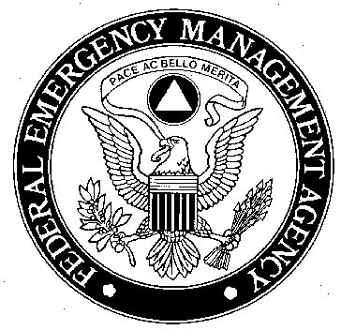

This page intentionally left blank
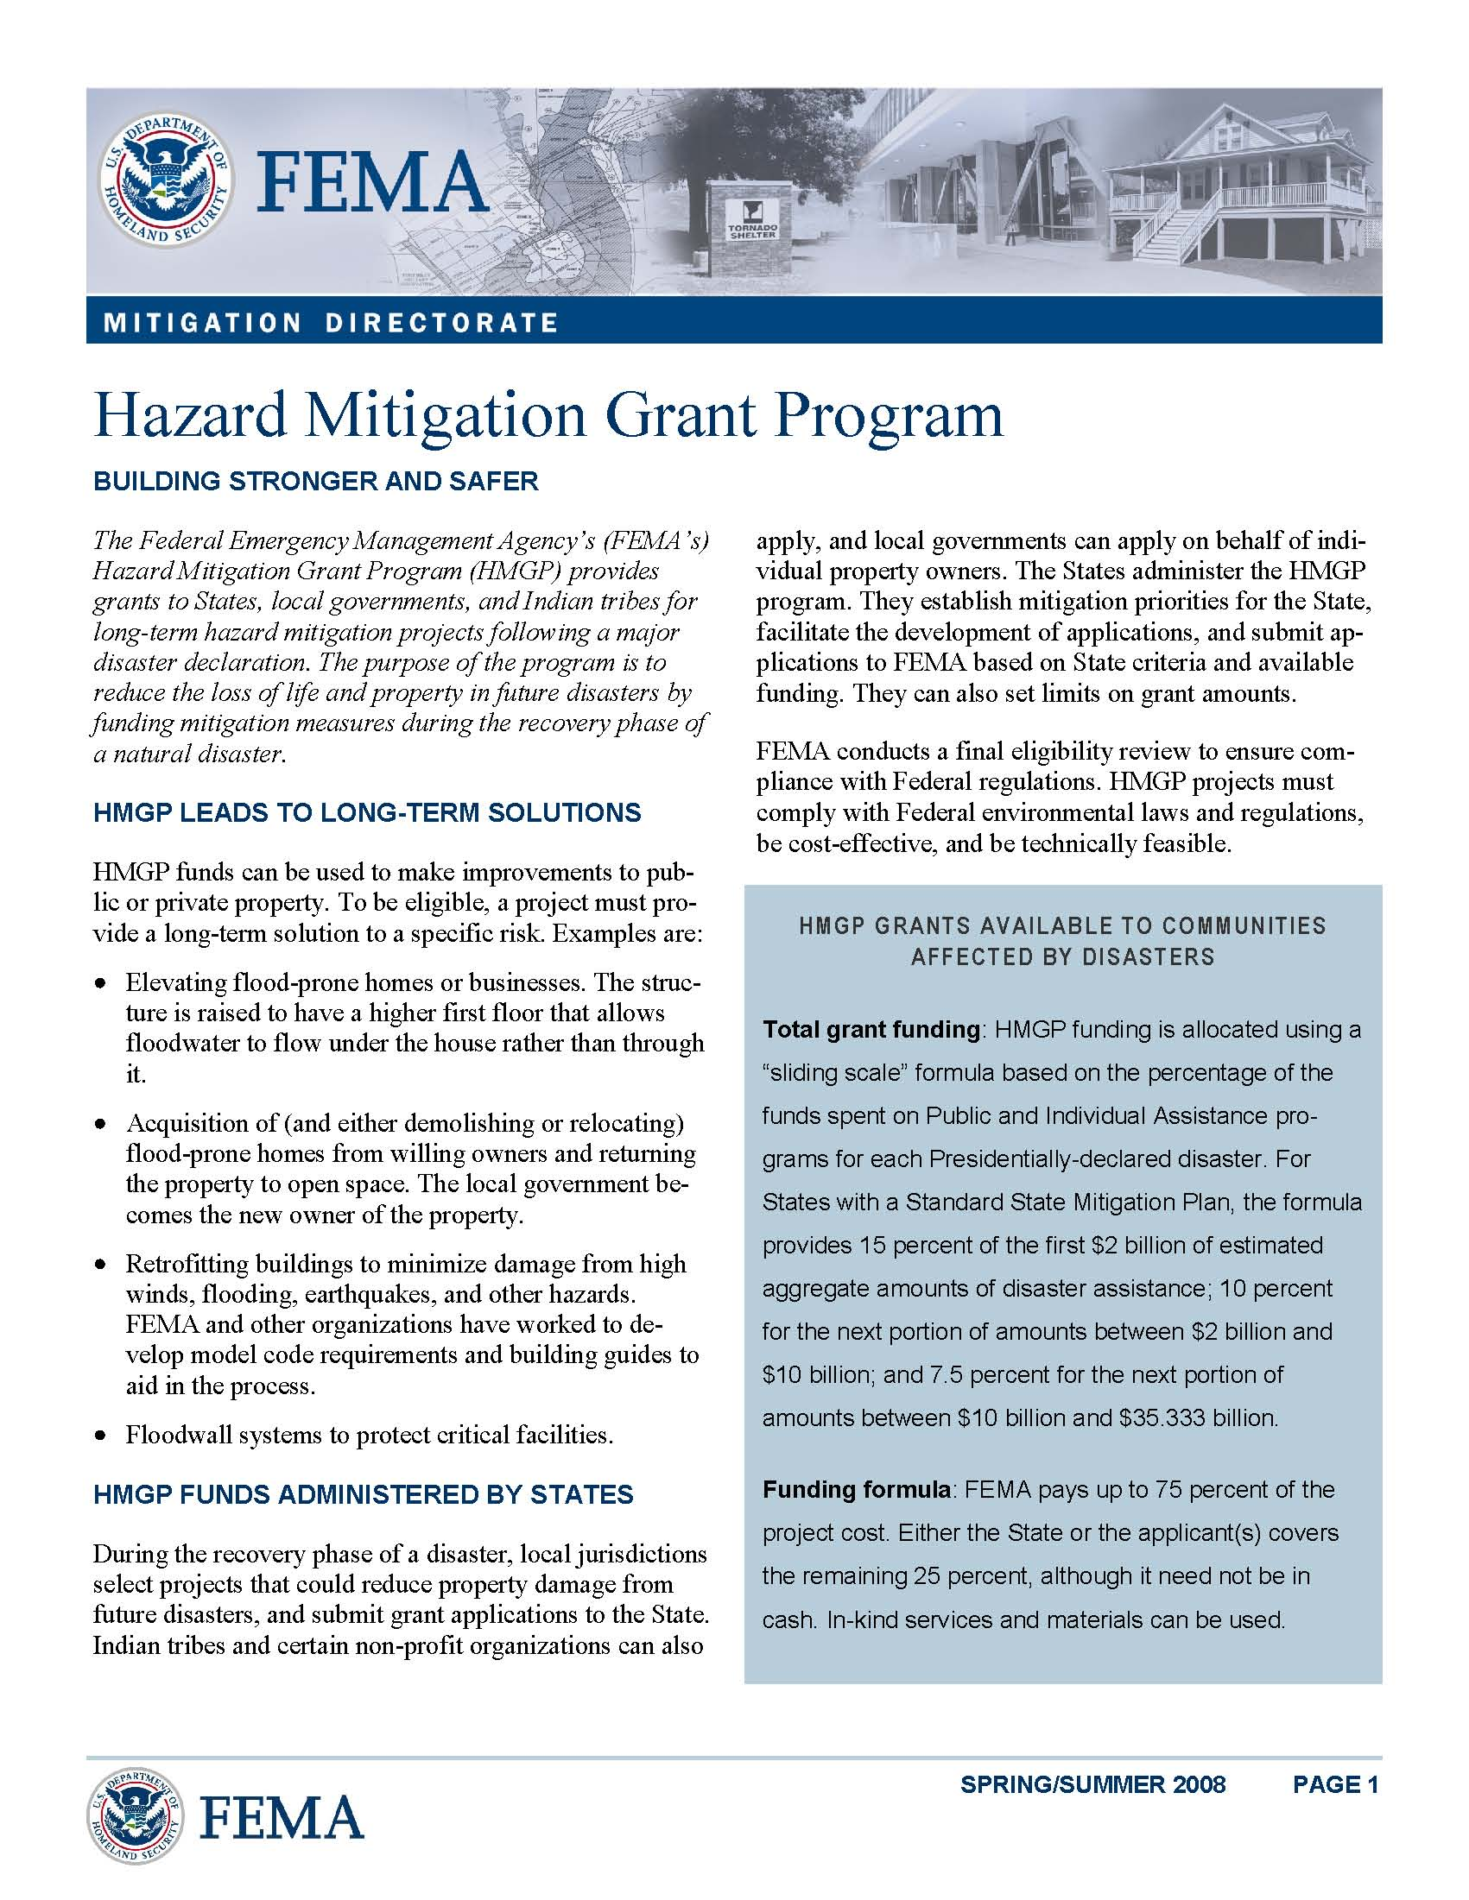
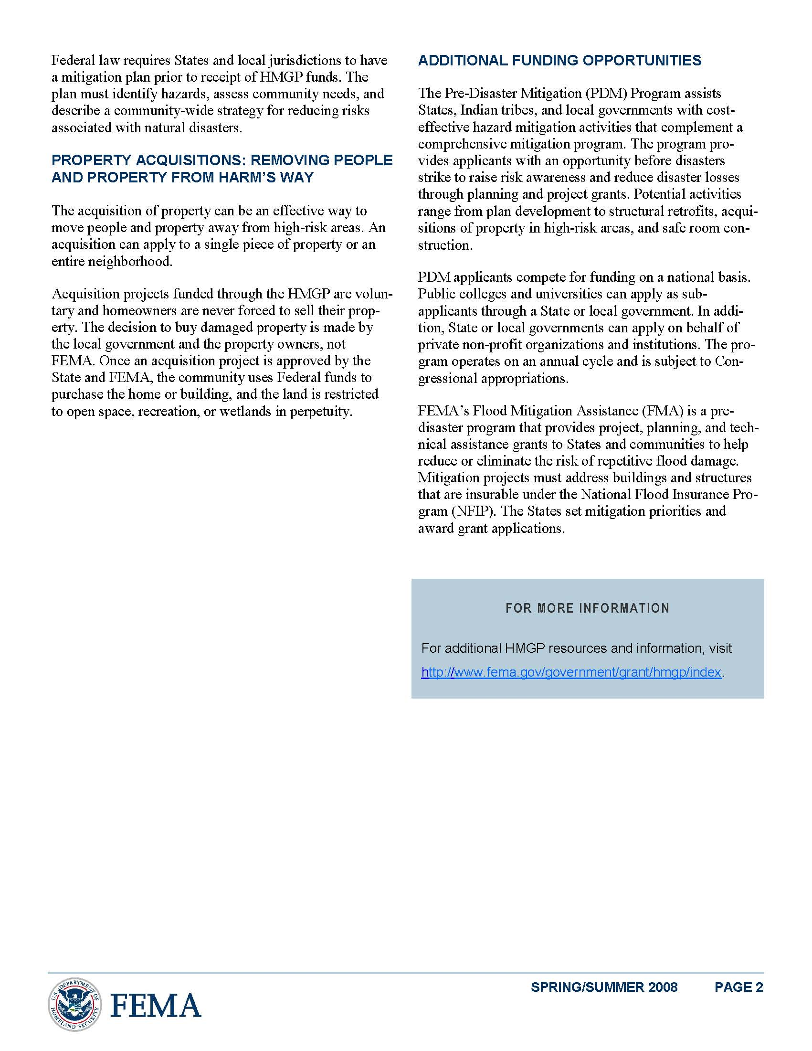
FLOOD MITIGATION ASSISTANCE (FMA) GRANT PROGRAM
This page intentionally left blank
The Flood Mitigation Assistance (FMA) Grant INFORMATION

The Flood Mitigation Assistance (FMA) grant program provides funding to communities so that cost-effective measures are taken to reduce or eliminate the long-term risk of flood damage to buildings, manufactured homes, and other structures insured under the NFIP. The long-term goal of FMA is to reduce or eliminate claims under the NFIP through mitigation activities.

Cost-share: 75% Federal/25% non-Federal. Of this amount, not more than one half may be provided from in-kind contributions.

ELIGIBLE PROJECT ACTIVITIES:

- Acquisitions/Relocations;

- Elevations;

- Dry Flood-proofing of non-residential structures;

- Minor Localized Flood Control Projects;

- Beach Nourishment Activities; and

- Demolition of NFIP-insured structures on acquired or restricted real property.

ELIGIBLE PLANNING ACTIVITIES:

Planning activities that develop State, Indian tribal, and local Flood Mitigation Plans that meet the planning criteria outlined in 44 CFR Part 78.

ELIGIBLE TECHNICAL ASSISTANCE ACTIVITIES:

- Solicitation, review, and processing of sub-applications;

- Assistance to sub-applicants for engineering feasibility, Benefit Cost Analysis (BCA), and Environmental and Historic Preservation documentation;

- Geo-coding mitigation projects;

- Managing grants;

- Technical monitoring;

- Plan reviews and planning workshops;

- Computer or GIS equipment (up to 15%).
INELIGIBLE PROJECT ACTIVITIES:

- Major flood control projects;

- Dry flood-proofing of residential structures;

- Mitigation reconstruction;

- Phased or partial projects;

- Studies that do not result in a completed mitigation project;

- Flood studies or flood mapping;

- Maintenance or repair projects;

- Generators, and related equipment;

- Warning and alert notification systems;

- Response and communication equipment;

- Properties that are subject to pending litigation; and

- Legal procedures related to litigation for an approved application or sub-application.

INELIGIBLE PLANNING ACTIVITIES:

- Flood studies or flood mapping;

- Risk assessments, technical assistance, information dissemination or workshops not resulting in a FEMA-approved Flood Mitigation Plan.

- Ground disturbing activities, and

- Non-flood planning activities.

FLOOD MITIGATION ASSISTANCE (FMA) GRANT - KEY POINTS:

NFIP PARTICIPATION:
All Applicants and sub-applicants must be participating in the National Flood Insurance Program (NFIP), and must not be on probation, suspended or withdrawn from the NFIP. FMA funds shall not be awarded for activities in non-participating communities. Properties in all FMA projects must be NFIP insured at the time of project application and flood insurance must be maintained at least through completion of the mitigation activity.

MITIGATION PLAN REQUIREMENT:
To be eligible for Project grants, an eligible sub-applicant must develop, and have approved by the FEMA Regional Administrator, a Flood Mitigation Plan in accordance with 44 CFR Part 78, at a minimum, by the close of the application period.

APPLICATION PROCESS:

FEMA requires Applicants to use the Electronic Grant Management System (eGrants). Only FMA grant applications submitted through eGrants will be accepted. If a sub-applicant does not use the eGrants system, the Applicant must enter the sub-applicants paper sub-application(s) into eGrants on their behalf using the Paper sub-application Intake function. Planning and Project sub-applications that follow the eGrants format are available for sub-applicants to print from the eGrants website. Applicants may provide paper supporting documentation that cannot be electronically attached to the eGrants application (e.g., engineering drawings, photos, maps, etc.). FEMA must receive the entire application by the application deadline, including any hard copy documentation.

BENEFIT-COST ANALYSIS:
A Benefit-Cost Analysis (BCA) is required for all mitigation project sub-applications and must be completed by Applicants/sub-applicants. A BCA will be required for all properties, including substantially damaged structures. The pilot alternate determination of cost-effectiveness may be used for certain insured NFIP repetitive flood loss properties.

This page intentionally left blank
PRE-DISASTER MITIGATION (PDM)
GRANT PROGRAM
This page intentionally left blank

Pre-Disaster Mitigation (PDM) Grant Program INFORMATION

Program Overview
The Pre-Disaster Mitigation (PDM) program provides funds to states, territories, Indian tribal governments, communities, and universities for hazard mitigation planning and the implementation of mitigation projects prior to a disaster event.
Funding these plans and projects reduces overall risks to the population and structures, while also reducing reliance on funding from actual disaster declarations. PDM grants are to be awarded on a competitive basis and without reference to state allocations, quotas, or other formula-based allocation of funds.

Application Development
FEMA's mitigation grants, including PDM, are provided to eligible Applicant States/Tribes/Territories that, in turn, provide sub-grants to local governments. The Applicant selects and prioritizes applications developed and submitted to them by local jurisdictions to submit to FEMA for grant funds.
Prospective Sub-applicants should consult the official designated point of contact for their Applicant State for further information regarding specific program and application requirements:
Mr. Richard Verville
Department of Safety
Homeland Security & Emergency Management
33 Hazen Drive, Concord, NH 03305
Phone: (603) 271-2231
Fax: (603) 223-3609
E-mail: richard.verville@hsem.nh.gov
Web Page: http://www.nh.gov/safety/divisions/bem/
Mitigation page: http://www.nh.gov/safety/divisions/bem/HazardMitigation/index.html

Application Process
- Applicants MUST use FEMA's Electronic Grants Management System (eGrants) to submit PDM grant applications to FEMA. Only PDM grant applications submitted through the eGrants system will be accepted.

Pre-Disaster Mitigation (PDM) Grant Program INFORMATION (cont.)

Application Process (cont.)
- If a state agency, Tribal, or local Sub-applicant does not use the eGrants system to submit their planning and/or project sub-application(s) to the Applicant, then the Applicant must enter the Sub-applicant’s paper sub-application(s) into the eGrants system on their behalf.

- Applicants must provide an original and two copies of any paper supporting documentation that cannot be electronically attached to the eGrants application (e.g., engineering drawings, photos, maps) to the appropriate Regional Office by the application deadline.

- Additional information regarding the eGrants system is available on the Mitigation eGrants System web page.

FEMA will provide assistance to Applicants and Sub-applicants during the application period. Additional information for FEMA mitigation grant activities, including project development and pre-award requirements, is available on the Grant Applicant Resources web page.

NH HOMELAND SECURITY GRANT PROGRAM (HSGP)

This page intentionally left blank

NH Homeland Security Grant Program (hsgp)
CONTACT INFORMATION

Contact

Name & Title: | Pam Urban-Morin  Grant Administrator
Mailing Address: | Commissioner’s Office  New Hampshire Department of Safety  33 Hazen Drive  Concord NH 03305
E-mail Address: | homelandgrants@safety.state.nh.us
Telephone: | In State and Local:  Facsimile:  TTY/TDD Relay Services: | (603) 271-7033  (603) 271-7660  (800) 735-2964

For a current list of available grant(s), please visit the following website:
http://www.nh.gov/safety/divisions/homeland/homelandgrants.html

This page intentionally left blank

Frequently Asked Questions - General Questions
- What is HSGP?
HSGP stands for Homeland Security Grant Program. The US Department of Homeland Security (DHS) allocates these funds to all states based on a Risk Analysis model along with competitive grant applications. In evaluating risk, DHS considers the populations in a particular area that could be at risk, the concentration of people in the area, and specific characteristics of their location that might contribute to risk, such as Intelligence Community assessments of threat, the economic impact of an attack, and the proximity to nationally critical infrastructure. The risk formula for HSGP is based on a 100 point scale comprised of threat (20 points) and vulnerability/consequence (80 points). They are broken down as follows:

  - Threat Index (20%): this variable reflects the Intelligence Community’s best assessment of areas of the country and potential targets most likely to be attacked.
  - Population Index (40%): this variable included nighttime population and military dependent populations for states and urban areas, based upon US Census Bureau and Department of Defense inputs. In addition, for urban areas, population density, commuters, and visitors were also factored into this variable, using data from private entities.
  - Economic Index (20%): this variable considers the economic value of the goods and services produced in either a state or an urban area. For states, this index was calculated using US Department of Commerce data on their percentage contribution to Gross Domestic Product. For Urban areas, a parallel calculation of Gross Metropolitan Product was incorporated based on data from Global Insight.
  - National Infrastructure Index (15%): this variable focuses on approximately 2,100 Tier I and Tier II critical infrastructure/key resource (CI/KR) assets that were identified by the DHS Office of Infrastructure Protection. Tier I assets or systems are those that if attacked could trigger major national or regional impacts similar to those experienced during Hurricane Katrina or 9/11. Tier II assets are other highly consequential assts with potential national or regional impacts if attacked.
  - National Security Index (5%): this variable considers the presence of three key national security factors: whether military bases are present in the state or urban area; how many critical defense industrial base facilities are located in the state or urban area; and the total number of people traversing international borders. Information on these inputs comes from the Department of Defense and DHS.
- What is SHSP?
SHSP stands for State Homeland Security Grant Program and is part of the overall HSGP funding to the state. SHSP supports the implementation of the State Homeland Security Strategy to address the identified planning, equipment, training, and exercise needs for acts of terrorism. In addition, SHSP supports the implementation of the National Preparedness Goal, the National Incident Management System (NIMS), and the National Response Plan.
- What is LETPP?
LETPP stands for Law Enforcement Terrorism Prevention Program and is part of the overall HSGP funding to the state. LETPP focuses upon the prevention of terrorist attacks and provides law enforcement and public safety communities with funds to support the following activities: intelligence gathering and information sharing through enhancing/establishing fusion centers; hardening high-value targets; planning strategically; continuing to build interoperable communications; and collaborating with non-law enforcement partners, other government agencies and the private sector.
- What other grant programs are included in the HSGP funds allocated to the State of New Hampshire?
Citizen Corps is the Department of Homeland Security’s grassroots initiative that encourages citizens to play a role in hometown security through personal preparedness and coordinated by over 1,200 local Citizen Corps Councils nationwide. CCP funds support Citizen Corps Council efforts to engage citizens in all-hazards prevention, protection, response and recovery.
The Metropolitan Medical Response System (MMRS) grant program funds support MMRS jurisdictions to further enhance and sustain an integrated, systematic mass casualty incident preparedness program that enables a first response during the first crucial hours of an incident.

This page intentionally left blank
Frequently Asked Questions - Statewide First Responder Fire/EMS Radio Interoperability Initiative
- What is APCO-25?
Project 25 (P25) or APCO-25 refer to a suite of standards for digital radio communications for use by federal, state/province and local public safety agencies in North America to enable them to communicate with other agencies and mutual aid response teams in emergencies.
- Are there any mobile radios available for distribution to local Fire/EMS agencies?
All mobile radios from surveys conducted in September 2003 and January 2004 have been installed or committed to a particular agency.
- Are there any portable radios available for distribution to local Fire/EMS agencies?
In January 2006, all Fire Departments and EMS agencies (both municipally and privately owned) were given the opportunity to communicate their portable radio needs. Based on those responses, radios were distributed to all departments.
- What if I did not get all the portables my department needs?
By the end of the portable radio project in October 2006, agencies received nearly all the radios requested, with the exception of privately owned EMS. Those privately owned EMS agencies received a number of radios based on the number of ambulances they own that respond to NH communities.
- Why were departments offered a choice of brand for the portable radios instead of all one brand? Is this still considered ‘interoperable’?
All the radio choices offered to departments are APCO-25 compliant radios; therefore they are all interoperable with NH’s communications system. Allowing a choice of several different products allowed for departments to fill their own communications needs, while remaining interoperable.
- What is next?
The goal of the Statewide Fire/EMS Radio Interoperability Initiative is for seamless flow of critical information among multi-jurisdictional and multi-disciplinary emergency responders, command scenes, agencies and government officials for the duration of emergency response operations in compliance with NIMS. The next steps toward that goal include: equipping all microwave frame-relay links in the State and Fire/EMS dispatch centers with P-25 compliant equipment to allow for greater capability to handle load; and determine local repeater and base station enhancement needs and address those needs.
- I don’t believe in digital. Do I have to move there with this project?
APCO-25 compliant equipment allows for analog and/or digital communication across an open-air interface. Even your older analog radios, replaced by this program, will be interoperable within this system.
- When does the warranty on my mobile or portable radio begin and end?
Three years from the date of installation/programming.
- I have ‘dead spots’ in my communication area. Will this project help?
Portables only have 5 watts of power and can only transmit within a limited scope. New mobile radio equipment may or may not assist in improving dead spots. Ultimately, additional infrastructure will be built to further address these issues.
- How are frequency and programming issues to be handled?
Channels 1-48 are assigned at the discretion of the local fire department. Channels 49-128 must be programmed per the statewide interoperability plan for fire and ambulances. Channels 129-256 are reserved for additional hospital and EMS-based communication per EMS needs.

Frequently Asked Questions - Statewide First Responder Fire/EMS Radio Interoperability Initiative (Cont.)

- Will the Department of Safety or Homeland Security Grant funding pay for replacement or upgrades of radios?
Your basic installation and programming of all mobile and portable radios is covered by this program, which should be completed at this time. These radios are now the property of your municipality and become the responsibility of the department to which they are issued. As such, the municipality must cover any upgrades. Replacement of radios due to loss or malfunction would also become the responsibility of the municipality.
- My town would like to purchase additional portable and mobile radios. Can we receive the State bid price?
Yes. When contacting your radio provider, be sure to ask for the State bid price.
- What does ‘intrinsically safe’ mean?
Intrinsically safe radios are those designed to be incapable of emitting an electrical spark, which would ignite volatile gases in the atmosphere. An intrinsically safe radio is not so unless the battery is also intrinsically safe. The battery must be made so that it cannot short out. The manufacturers must limit how warm the battery can get and limit the flow of current through the battery.
- How can we upgrade the accessories that were issued, and can we dispose or sell the original accessories?
The radios were issued as a unit or package, and must be inventoried as such. In the event of an audit, all the accessories that were distributed with your radio must be accounted for. If your department determines you would like to purchase an upgrade or a replacement, you may do so with an understanding that the initial accessories are kept on hand.
- Who determines my department’s distribution process for the radios?
Particularly since each department’s organizational and procedural makeup is unique, the Chief, or staff member designated by the Chief, can determine the best method of distribution. There are departments that have issued a portable radio to each active firefighter to keep with him/her at all times, while other departments have chosen to keep all the radios at the station or on apparatus for use only during specific events or calls.
- What are the inventory requirements of these radios?
It is recommended that each radio be inventoried with the serial number and signed out with a clear understanding that the assignee is responsible for that radio. In the event that a volunteer or staff member resigns or for some other reason is no longer an active member of the department, a procedure should be in place for the return of that radio.
- How are depreciation values based, and how long must these radios be kept?
The depreciation values are based on the set rules used by the accountant. When the equipment is valued at $100 or less, the town, at their own discretion, can dispose of the radios.
- If a privately owned EMS goes out of business or no longer serve the NH communities, what are the requirements of returning those radios?
Since the radios are the property of the municipality in which the private EMS serves (or with whom the MOUs were set up) the privately owned ambulances are required to turn over the radios to the town. It is also recommended that the privately owned EMS notify the Grants Management Unit as will as the Bureau of Emergency Medical Services that they are no longer conducting business for the State of New Hampshire.

Frequently Asked Questions - Statewide First Responder Fire/EMS Radio Interoperability Initiative (Cont.)
- What should be done with the old radios that the municipality owned prior to being issued new radios?
Your older analog radios can be issued to road agents, water and public works departments, Emergency Management Directors and staff, and or be used as a cache for emergencies when more radios are needed.
- Now that we have been using our radios my staff has determined that we may have chosen the wrong brand/We are unhappy with our brand. Can we trade these radios for another brand?
No. Since all recipients of the portable radios were given a choice as to the brand of radios, and the purchase was made specifically for your department, it is too late to be considered for trade to another brand.
- We purchased a new ambulance/truck/command vehicle? Can we have a mobile radio?
It is recommended that when such a purchase is made that your department/municipality should budget for a mobile radio along with the purchase. The radio interoperability initiative has shifted its priority to infrastructure and there may not be funds for the purchase of additional radios.
- One of our radios was stolen. Do we need to notify anyone?
First, contact your Police Department to file a report. Then notify the Grants Management Unit in writing with the details, including the police report and serial number of the radio. Your department will need to replace the radio with your own funds.

This page intentionally left blank

